Full Name: Nguyen Van Duy Manh
Student Code: 29211100024

I. Assignment 1: The "Legacy-to-Cloud" Migration Case Study

1. System Boundary Diagram

1.1. Interactive labeling
- Requirement 1: The system must pull real-time "Member Discounts" from an external legacy SQL Server (Maintained by the headquarters): EIF
- Requirement 2:
- Data entry staff: EI
- The "Local Stock" database table and the "Master Inventory" table: ILF x 2
- Requirement 3:
- A "Dynamic Pricing Report" is generated: EO
- Calculates prices based on a complex algorithm involving competitor prices (from an external API) and current stock levels: EIF

1.2. Context Diagram
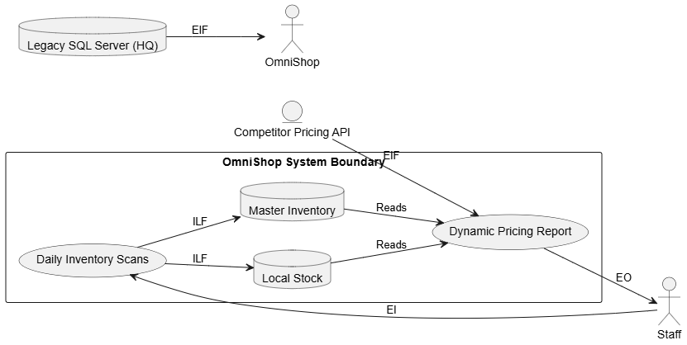

2. The Calculation
- Using the Average complexity weights:
- 1 EI = 4
- 1 EO = 5
- 2 EIF = 2 x 7 = 14
- 2 ILF = 2 x 10 = 20
Total Unadjusted Function Points (UFP) = 4 + 5 + 14 + 20 = 43

- Critical Thinking Question:
- If Requirement 3 only displayed raw data without any mathematical formulas or derived calculations, it would no longer be an EO. According to standard measurement rules, retrieving and displaying data without altering it or performing calculations makes it an EQ.
- The average weight for an EO is 5 points, but the EQ is only 4 points. The total number of UFP will decrease by 1 point (43 – 1 = 42).

3. AI-Proof Reflection
- VAF Factors (Cloud vs Offline)
- F2 - Distributed Data Processing (Rating: 5): Offline POS uses a simple local database. However, a 2026 cloud platform (OmniShop) uses multi-region databases (like AWS DynamoDB) for high availability. Syncing real-time data across these distributed nodes makes the processing complexity extremely high
- F13 - Multiple Sites (Rating: 5): The old system ran locally at a single store. The new cloud system serves the whole retail chain concurrently via the internet. Handling multi-tenant architecture and secure traffic from various geographic locations at the same time justifies a rating of 5

II. Assignment 2: The "Agile Scope Creep" Challenge

1. Value Adjustment Factor (VAF) Math

1.1. Initial VAF
- All 14 technical factors were rated as "Average" (3), except for "Reusability" (F10) and "Multiple Sites" (F13), which were "Not Relevant" (0) 14 – 2 = 12
- 12 factors rated Average: 12 x 3 = 36
- F10 and F13 are Not Relevant: 2 x 0 = 0
- Original Total = 36 + 0 = 36
- Original VAF = 0.65 + (0,01 x 36) = 1,01
- Original UFC (UFP) = 150

1.2. The Change
- F1: Customer demands are increasing (Average High) Difference = +2
- Supporting 5 OS platforms changes F13 from 0 to max complexity (5) Difference = +5.
- New TDI = 36 + 2 + 5 = 43
- New VAF = 0.65 + (0.01 x 43) = 1.08
- New Adjusted FP (AFP) = 150 x1.08 = 162

2. Practical Comparison
- The project changes add 12 (162 – 150 = 12) FP
- Number of additional lines of code
- Java averages about 53 LOC per FP 12 x 53 = 636 lines of code
- Visual Basic averages about 32 LOC per FP 12 x 32 = 384 lines of code

3. Industry Analysis
In my opinion, Function Point Analysis (FPA) are not effective to measure the size of a modern Microservices architecture. I think it is very much hard and probably not useful for modern software team. FPA is originally create many years ago for traditional monolithic system. In monolithic, the whole application is just one big system running together. But Microservices is completely different because the software divide into many small independent service that running on different server.
The biggest problem I seeing is how to define the System Boundary. In standard FPA rule, find the correct boundary is critical for accurate measurement. If we counting each small microservice as a separate system boundary, the Function Point score will increase too much high. This happen because microservices must communicate together using specific Cloud APIs like AWS API Gateway or RESTful HTTP calls all the time. Every time they sharing data, FPA force us to count it like an External Interface File (EIF) or external transaction. Because of this, the total size is fake inflate just because the services talking to each other too much. A study evaluate microservice size against monolithic found that convert to microservices increase the Function Points by 45 percent. This mean the score not show the real business value of the app.
On the other hand, if we grouping all microservices into one single big boundary like the old monolith, FPA also fail to measure it. If we do this, FPA ignore all the complex technical work under the system. Manage distributed databases like MongoDB or AWS DynamoDB, fix network delay, and deploy CI/CD pipelines using tools like Docker and Kubernetes is very hard work for developer. But the old 14 Value Adjustment Factors (VAF) from IFPUG not have anything to measure these modern cloud task well.
Another reason is Agile development. Microservices team always using Agile and sprint. Requirement change very fast mid-sprint. Counting FPA need a lot of manual analysis time. The team not have time to recount everything every two weeks.
So, because this boundary issues and fast change, FPA is too heavy and slowly. Development team should using Agile method like Story Points in tools like Jira instead. Story points are much faster to estimate during a quick Sprint planning meeting, which fits the modern 2026 software development style perfectly.
References:
https://www.researchgate.net/publication/326163347_A_Case_Study_on_Measuring_the_Size_of_Microservices
https://www.youtube.com/watch?v=Uc7SLJbKAGo&t=4s

